ABSTRACT

Data visualization is the discipline of trying to understand data by placing it in a visual context so that patterns, trends and correlations that might not otherwise be detected can be exposed. Matplotlib is the most popular Python plotting library. It is a low-level library with a MATLAB-like interface which offers lots of freedom at the cost of having to write more code. Pandas DataFrame is two-dimensional size-mutable, potentially heterogeneous tabular data structure with labelled axes (rows and columns). A DataFrame is a two-dimensional data structure, i.e., data is aligned in a tabular fashion in rows and columns.
In this project, we combine all the above-mentioned DataFrame, Data visualization in Python to analyse the data which is stored in csv format. The data is then later imported using read_csv() function for visualization of the data in the form of different charts. We took the credit card related data to work with our project.

ACKNOWLEDGMENT

We thank Lord Almighty for the blessings he had bestowed on us which resulted in finalization of our project.
We would like to express our sincere gratitude to this institution, St. Kuriakose Public School, Mariamala, Kaduthuruthy & our Manager Rev. Fr. BINO CHERIYIL for the worthy support extended to us. We also thank and express sincere gratitude to our honourable Principal Ms. RENJI WILSON CHOCKATTU for providing us with best facilities and atmosphere for our project development and its realization. We are grateful to the Head of the Department, Ms. NILNA BABU, for her constant encouragement and support.
We are highly obliged to our project coordinators and guides Mr. GODWIN JOSEPH and Ms. NILNA BABU, for their valuable guidance and help during the course of this project work. We also like to express our gratitude to the lab staffs who helped us to make the project a success.
This acknowledgement will stand incomplete if our parents, friends, seniors & classmates are not thanked for enduring their prayers and support to us, which was inevitable for the realization of this work. Last but not the least we are thankful to each other in this project group for being co-operative, patient and hardworking for the successful completion of this project.

GROUP MEMBERS

HANNA MARIA BINU
HARIPRIYA HAREESH
JEON JOSEPH SHIJO

TABLE OF CONTENTS

CHAPTER.NO | TITLE | PAGE.NO
 | ABSTRACT | 1
 | ACKNOWLEDGMENT | 2
 | GROUP MEMBERS | 3
 | TABLE OF CONTENTS | 4
1. | INTRODUCTION  1.1 General Introduction  1.2 Introduction to Python  1.3 Introduction to Pandas  1.4 Introduction to Pandas DataFrame  1.5 Introduction to Data Visualization  1.6 Introduction to csv files | 6  6  6  6  7  7  7
2. | OBJECTIVES  2.1 Objective of the project | 8  8
3. | SYSTEM REQUIREMENTS  3.1 Minimum Hardware requirements  3.2 Minimum Software requirements | 9  9  9
4. | SYSTEM STUDY  4.1 Existing Systems  4.2 Proposed Systems | 10  10  10
5. | SYSTEM DESIGN  5.1 System Design  5.2 Output Design  5.3 Input Design  5.4 Database Design | 11  11  11  11  11
6. | SOURCE CODE | 12
7. | OUTPUT WINDOW  7.1 Main Menu Window  7.2 csv File  7.3 DataFrame Displayed From csv  7.4 Run-Time Sample Output Windows  7.5 Output Chart | 20  20  20  21  21  23
8. | CONCLUSION | 25
9. | REFERENCES | 26

CHAPTER 1
INTRODUCTION

1.1 GENERAL INTRODUCTION
The world is changing rapidly. The era of industrialization has made humans completely dependent on automation. Today computers are common, cheap and are active in almost every field of science and technology. The robotic brains have made advanced development in the field of science, information, communication, technology and commerce. The main functions of managing information like collection of data, classification, storing and summarizing are all done with the help of systems.
As a result, a great deal of man-force is considerably reduced. Thus computers have become a part of our daily life. Schools and colleges are entirely dependent on computers for their smooth and easier management. It reduces the burden of people. It helps to manage great amount of data expensively and with such a great accuracy because of its bookkeeping practice that previously prevailed in schools and colleges have become outdated, and all records today are maintained via computers. This helps in promoting greater efficiency.

1.2 INTRODUCTION TO PYTHON
Python is a widely used general-purpose, high level programming language. It was created by Guido van Rossum in 1991 and further developed by the Python Software Foundation. It was designed with an emphasis on code readability, and its syntax allows programmers to express their concepts in fewer lines of code.
Python is a programming language that lets you work quickly and integrate systems more efficiently.

1.3 INTRODUCTION TO PANDAS
Pandas is an open-source Python library providing high-performance data manipulation and analysis tool using its powerful data structures. [Pandas] is derived from the term "panel data", an econometrics term for data sets that include observations over multiple time periods for the same individuals. Pandas offers many data structures to handle variety of data.
Pandas is a package commonly used to deal with data analysis. It simplifies the loading of data from external sources such as text files and databases, as well as providing ways of analyzing and manipulating data once it is loaded into your computer. The features provided in pandas automate and simplify a lot of the common tasks that would take many lines of code to write in the basic Python language.

1.4 INTRODUCTION TO PANDAS DATAFRAME
A DataFrame in Pandas stores data in two-dimensional way. It is a two-dimensional labelled array, which is actually an ordered collection of columns where columns may store different types of data, e.g., numeric or string or floating point or Boolean type etc.
- It has two indexes or we can say that two axes – a row index(axis=0) and column index (axis=1)
- Each value is identifiable with the combination of row index and column index.
- The row index is known as index in general and the column index is called the column-name.
- The indexes can be of numbers or letters or strings.
- There is no condition of having all data of same type across columns; its columns can have data of different types.
- You can easily change its values, i.e., it is value-mutable.
- You can add or delete rows/columns in a DataFrame. In other words it is size-mutable.

1.5 INTRODUCTION TO DATA VISUALIZATION
Data visualization basically refers to the graphical or visual representation of information and data using visual elements like charts, graphs, maps, etc.
Data visualization in Python can be done via many packages. One example of a package is matplotlib. The matplotlib is a Python library that provides many interfaces and functionality for 2D- graphics similar to MATLAB’s various forms.
The Matplotlib library offers many different named collections of methods; PyPlot is one such interface. PyPlot is a collection of methods within matplotlib which allows user to construct 2D plots and graphs easily and interactively. matplotlib is a 2D plotting library that helps in visualizing figures.

1.6 INTRODUCTION TO CSV FILES
A simple way to store big data sets is to use CSV files (comma separated files).
CSV files contain plain text and is a well-known format that can be read by everyone including Pandas. The CSV file acts as the database where we store all the data related to the program for saving, accessing and modification of the data.

CHAPTER 2
OBJECTIVES

2.1 OBJECTIVE OF THE PROJECT

This project ‘CREDIT CARD ANALYSIS’ aims to work with the data and visualize the data in the form of different charts and graphs using Python and its different modules. The software is designed in Python IDLE script mode and uses CSV file as background.

The objective of the project is to use Python DataFrame concept for analysing the details of different customer’s credit card details. The project also aims to view,add,delete the data and also to summarise the data.The data is stored in csv format and accessed using read_csv() function in to our project to plot different graphs as per the choice of the end user.

CHAPTER 3
SYSTEM REQUIREMENTS

3.1 MINIMUM HARDWARE REQUIREMENTS

- x86 64-bit CPU (Intel / AMD architecture)
- 4 GB RAM
- 5 GB free disk space
- Display – Monochrome/VGA
- Standard QWERTY Keyboard
- Mouse

3.2 MINIMUM SOFTWARE REQUIREMENTS

- Modern Operating System:
  - Windows 8 or higher
  - Mac OS X 10.11 or higher, 64-bit
  - Linux: RHEL 6/7, 64-bit (almost all libraries also work in Ubuntu)
- Python IDLE v3.7 or later
- Spreadsheet program, such as Microsoft Excel, OpenOffice Calc for csv file operation.
- Modules – pandas, matplotlib.pyplot , numpy

CHAPTER 4
SYSTEM STUDY

4.1 EXISTING SYSTEM

The existing system forces Us to rely on any software or online websites for storing the data and analysing the data for obtaining output. This could limit the possibilities as the software available for such data analysis is always restricted to the developer’s choices and ideas.

Also, the data collected has to be entered to such software which is time- consuming. Also, it leads to confusions, greater workload and at times tedious too. Developing an own program can be always customisable and changed as per own decisions and requirements. This is not always possible with most existing software/system.

4.2 PROPOSED SYSTEM

In the proposed system, we are using Python for creating data and storing it with help of DataFrame and CSV files. This can be used for data visualization. The project is done in such a way that we are incorporating functions to access the data as per the user’s choice. This will help to obtain the desired output as per the choice of the user. We also provide the user to continue/exit the program at any point of time.

CHAPTER 5
SYSTEM DESIGN

5.1 SYSTEM DESIGN

System design is an approach to the creation of the system. It involves selection of system functions, drawing of the system, flowchart etc. It provides the understanding and procedural details necessary for implementing the system recommended in the feasibility studies.
The activities carried in the design phase are as follows:
- Output design
- Input design
- Database design

5.2 OUTPUT DESIGN
Computer output is the means of directing information to the user. Efficiency in output design helps in decision making and improving the relationship between the system and the user. The design team defines the sketches into detailed description of the output by planning the output with the specific medium. Printout is designed based on the output requirements of the user.

5.3 INPUT DESIGN

Input system is a phase system designing. It is the process of converting the collected input data into the computer-based format. The aim of designing input data is to make data entry easy. The phase is often the first place of detecting and correcting errors, during data entry one should know the space allocated for each field, the field sequences that matches the source document and the format in which the data is to be entered. The objective of input data design is to create an input layout that is easy to follow and that which does not include operational errors.

5.4 DATABASE DESIGN

The user uses database to store integrated data that is input. It is organized so that various files can be accessed through a single reference. Here we use csv files to store the data and access the same using

CHAPTER 6
SOURCE CODE

# project name : credit card analysis
import pandas as pd
import matplotlib.pyplot as plt
df = pd.DataFrame()
csv_file = "E:\Project_2021\Credit_card_adata_analysis\BankChurners.csv"

def read_csv_file():
df = pd.read_csv(csv_file)
print(df)

# name of function : clear
# purpose : clear output screen

def clear():
for x in range(65):
print()

# name of function : data_analysis_menu
# purpose : To analysis the data from csv file

def data_analysis_menu():
df = pd.read_csv(csv_file)
while True:
clear()
print('\n\nD A T A A N A L Y S I S M E N U ')
print('-'*50,'\n')
print('1. Show Whole DataFrame')
print('2. Show Columns')
print('3. Row Top Rows')
print('4. Row Bottom Rows')
print('5. Show Specific Column')
print('6. Add a New Record')
print('7. Add a New Column')
print('8. Delete a Column')
print('9. Delete a Record')
print('10. Card Type User')
print('11. Gender wise User')
print('12. Data Summary')
print('13. Exit (Move to main menu)')
ch = int(input('\n\nEnter your choice:\t'))
if ch == 1:
print(df)
wait = input('\n\n\n Press any key to continue.....')
if ch == 2:
print(df.columns)
wait = input('\n\n\n Press any key to continue.....')
if ch == 3:
n = int(input('Enter Total rows you want to show :'))
print(df.head(n))
wait = input('\n\n\n Press any key to continue.....')
if ch == 4:
n = int(input('Enter Total rows you want to show :'))
print(df.tail(n))
wait = input('\n\n\n Press any key to continue.....')
if ch == 5:
print(df.columns)
col_name = input('Enter Column Name that You want to print : ')
print(df[col_name])
wait = input('\n\n\n Press any key to continue.....')
if ch == 6:
a = input('Enter Customer ID :')
b = input('Enter Customer Type :')
c = input(' Enter Customer Age:')
d = input('Enter Customer Gender :')
e = input('Enter Customer Dependent Count :')
f = input('Enter Education Level :')
g = input('Enter Marital Status :')
h = input('Enter Income Category :')
i = input('Enter Card Category :')
j = input('Enter Month on Book')
k = input('Enter Total Relationship count :')
l = input('Enter Total Month Inactive in last 12 month :')
m = input('Enter Total Contacted in last 12 months :')
n = input('Enter Credit Limit :')
o = input('Enter Revolving Balance :')
p = input('Enter Average Open to Buy Card :')
q = input('Enter Total amount change Q4 to Q1 :')
r = input('Enter Total Transaction amount :')
s = input('Enter Total Transaction Credit:')
t = input('Enter Total Credit Change Q4 Q1 :')
u = input('Enter Average Utilization Ratio :')
#dictionary
data = {
'clientID': a, 'Type': b, 'age': c,'gender': d,'Dependent_count': e, 'Educational_Level': f,'Marital_Status': g, 'Income_Category':h,'Card_Category':i,'Months_on_book':j,'Total_Re lationship_count':k, 'Month_Inactive_12_month':l,'Contacts_count_12_mon':m,'Credit_L imit':n, 'Total_Revolving_Bal':o,'Avg_Open_To_Buy':p,'Total_Amt_chng_Q4_ Q1':q,'Total_Trans_Amt':r, 'Total_Trans_Ct':s,'Total_Ct_Chng_Q4_Q1':t,'Average_Utilization_Rat ion':u
}
df = df.append(data, ignore_index=True)
print(df)
wait = input('\n\n\n Press any key to continue.....')
if ch == 7:
col_name = input('Enter new column name :')
col_value = int(input('Enter default column value :'))
df[col_name] = col_value
print(df)
print('\n\n\n Press any key to continue....')
wait = input()

if ch == 8:
col_name = input('Enter column Name to delete :')
del df[col_name]
print(df)
print('\n\n\n Press any key to continue....')
wait = input()

if ch == 9:
index_no = int(input('Enter the Index Number that You want to delete :'))
df = df.drop(df.index[index_no])
print(df)
print('\n\n\n Press any key to continue....')
wait = input()

if ch == 10:
print(df.columns)
print(df['Type'].unique())
tipe = input('Enter Card Type ')
g = df.groupby('Type')
print('Card Type : ', tipe)
print(g['Type'].count())
print('\n\n\n Press any key to continue....')
wait = input()

if ch == 11:
df1 = df.Gender.unique()
print('Available Gender :', df1)
print('\n\n')
schName = input('Enter Gender Type :')
df1 = df[df.Gender == schName]
print(df1)
print('\n\n\n Press any key to continue....')
wait = input()

if ch == 12:
print(df.describe())
print("\n\n\nPress any key to continue....")
wait = input()
if ch == 13:
break

# name of function : graph
# purpose : To generate a Graph menu
def graph():
df = pd.read_csv(csv_file)
while True:
clear()
print('\nGRAPH MENU ')
print('-'*50)
print('1. Whole Data LINE Graph\n')
print('2. Whole Data Bar Graph\n')
print('3. Bar Graph By Education Level\n')
print('4. Bar Graph By Income Level\n')
print('5. Exit (Move to main menu)\n')
ch = int(input('Enter your choice:\t'))

if ch == 1:
g = df.groupby('Gender')
x = df['Gender'].unique()
y = g['Gender'].count()
#plt.xticks(rotation='vertical')
plt.xlabel('Gender')
plt.ylabel('Total Credit Card Users')
plt.title('Credit Card User- Gender wise')
plt.grid(True)
plt.plot(x, y) #line graph
plt.show()

if ch == 2:
g = df.groupby('Gender')
x = df['Gender'].unique()
y = g['Gender'].count()
#plt.xticks(rotation='vertical')
plt.xlabel('Gender')
plt.ylabel('Total Credit Card Users')
plt.title('Credit Card User- Gender wise')
plt.bar(x, y) #bar graph
plt.grid(True)
plt.show()
wait = input()

if ch == 3:
g = df.groupby("Education_Level")
x = df['Education_Level'].unique()
y = g['Education_Level'].count()
plt.bar(x, y)
#plt.xticks(rotation='vertical')
plt.grid(True)
plt.title('Education Level wise Card User')
plt.xlabel('Education Level')
plt.show()
wait = input()

if ch == 4:
g = df.groupby("Income_Category")
x = df['Income_Category'].unique()
y = g['Income_Category'].count()
plt.grid(True)
plt.title('Credit Card User- Income Group')
plt.xlabel('Income Group')
plt.ylabel('Card Users')
plt.bar(x,y)
plt.show()

if ch == 5:
break

# function name : export_menu
# purpose : function to generate export menu
def export_menu():
df = pd.read_csv(csv_file)
while True:
clear()
print('\n\nEXPORT MENU ')
print('-'*50)
print()
print('1. CSV File\n')
print('2. Excel File\n')
print('3. Exit (Move to main menu)')
ch = int(input('Enter your Choice :\t '))

if ch == 1:
df.to_csv('E:\Project_2021\Credit_card_adata_analysis\BankChurner s_backup.csv')
print('\n\nCheck your new file "bankchurner_backup.csv" on E: Drive.....')
wait = input('\n\n\n Press any key to continue.....')

if ch == 2:
df.to_excel('E:\Project_2021\Credit_card_adata_analysis\BankChurn ers_backup.xlsx')
print('\n\nCheck your new file "bankchurner_backup.xlsx" on E: Drive.....')
wait = input('\n\n\n Press any key to continue.....')

if ch == 3:
break

#main menu function
def main_menu():
clear()
while True:
clear()
print('MAIN MENU ')
print('-'*50)
print()
print('1. Read CSV File\n')
print('2. Data Analysis Menu\n')
print('3. Graph Menu\n')
print('4. Export Data\n')
print('5. Exit\n')
choice = int(input('Enter your choice :\t'))

if choice == 1:
read_csv_file()
wait = input('\n\n Press any key to continue....')

if choice == 2:
data_analysis_menu()
wait = input('\n\n Press any key to continue....')

if choice == 3:
graph()
wait = input('\n\n Press any key to continue....')
if choice == 4:
export_menu()
wait = input('\n\n Press any key to continue....')

if choice == 5:
break
clear()

# call your main menu
main_menu()
print(“\nThank you for using..”)

CHAPTER 7
OUTPUT WINDOW

7.1 MAIN MENU WINDOW

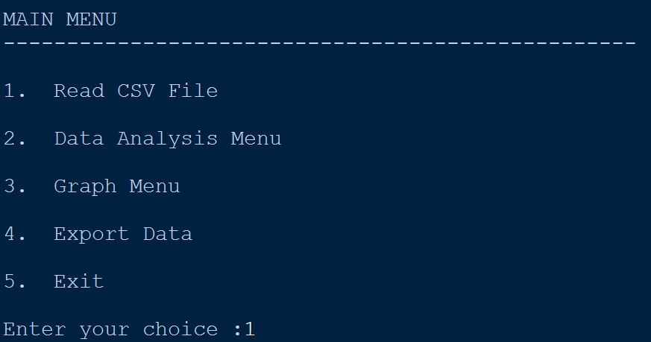

7.2 CSV FILE

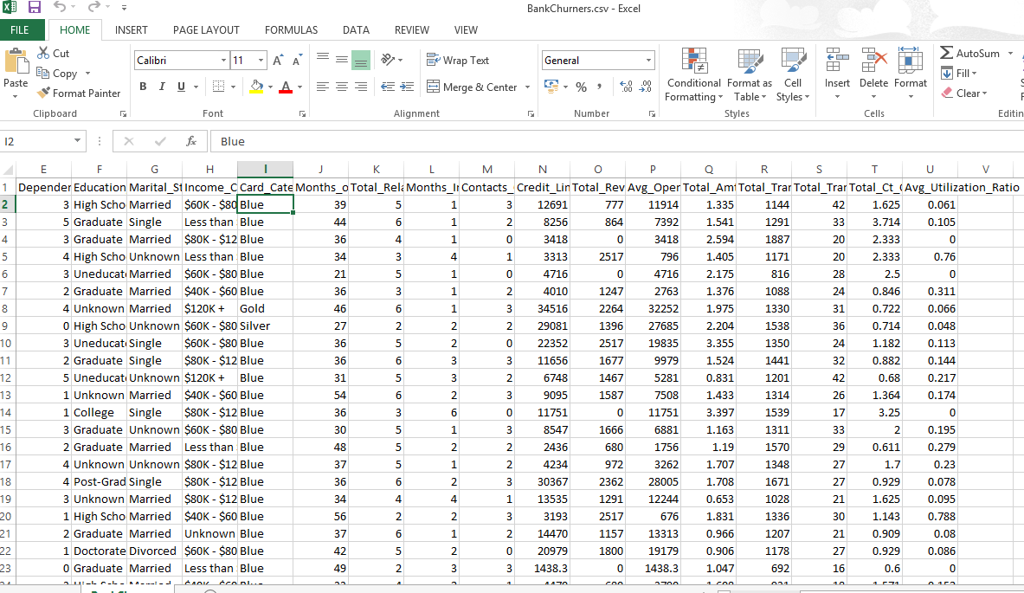

7.3 DATAFRAME DISPLAYED FROM CSV

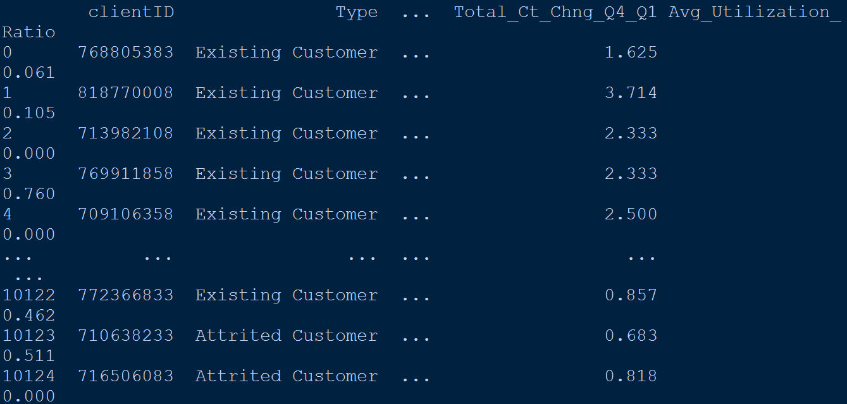

7.4 RUN-TIME SAMPLE OUTPUT WINDOWS

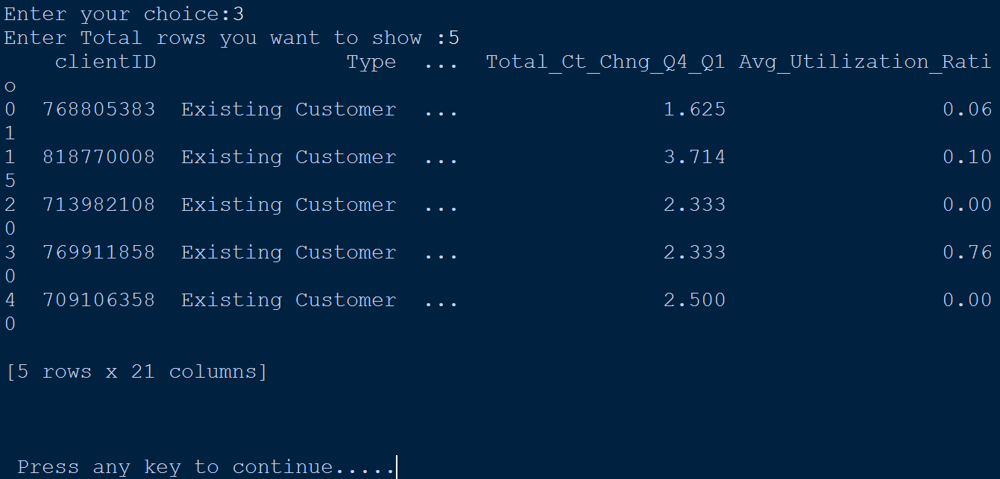

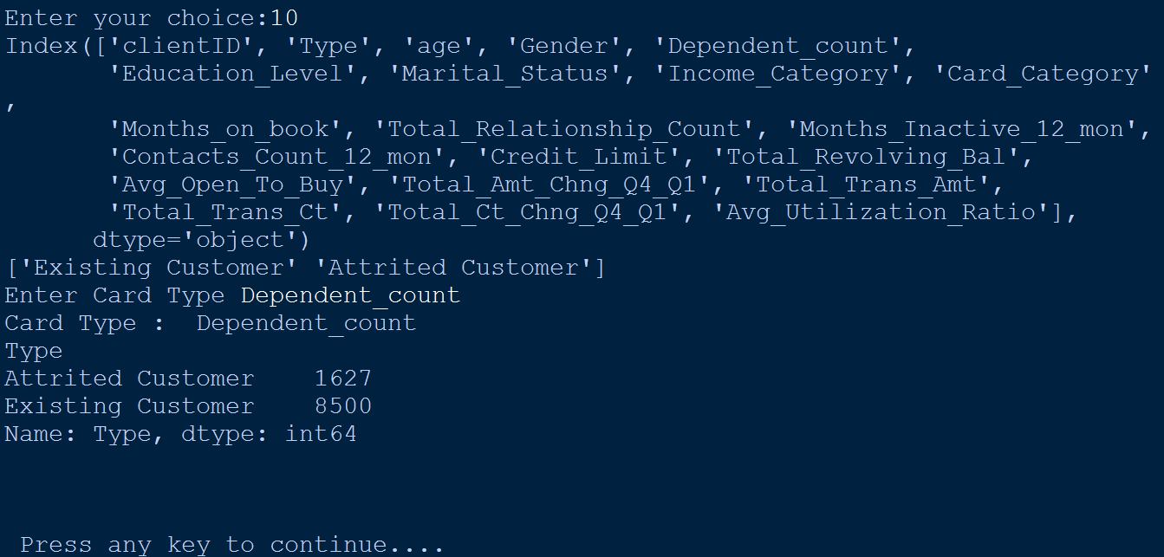

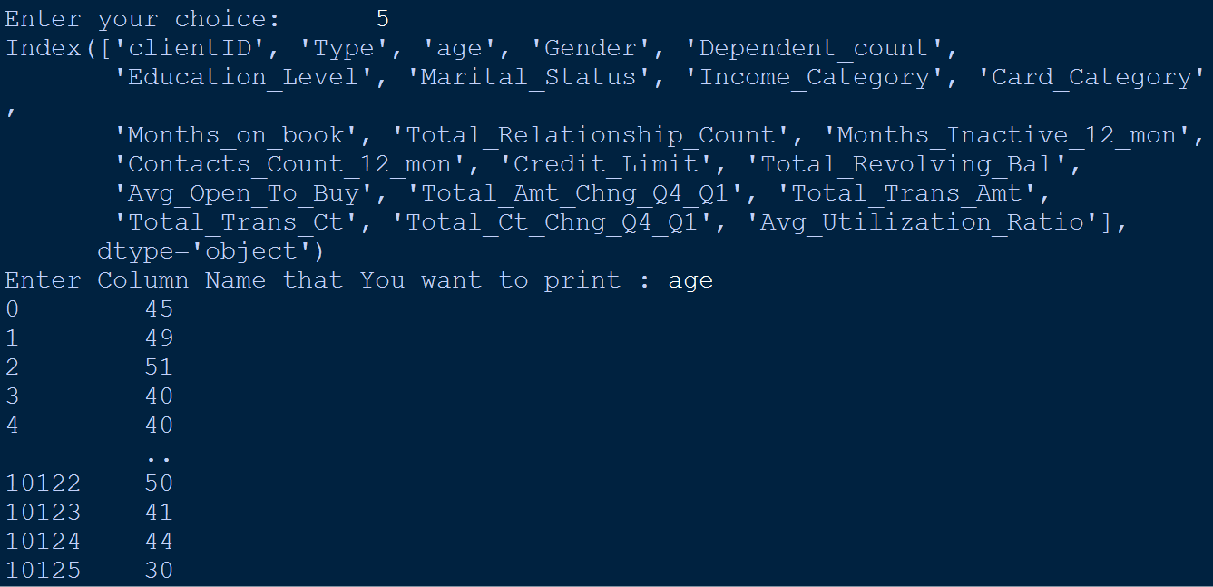

7.5 OUTPUT CHART

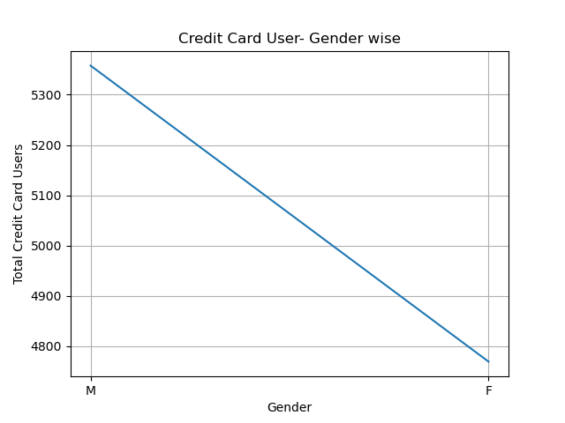

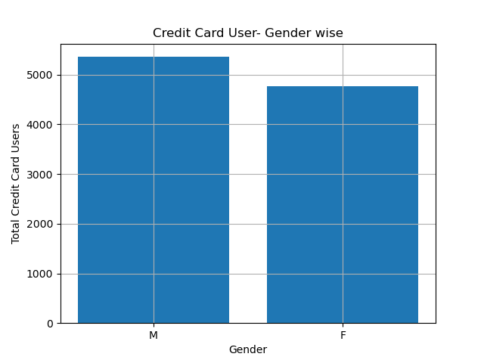

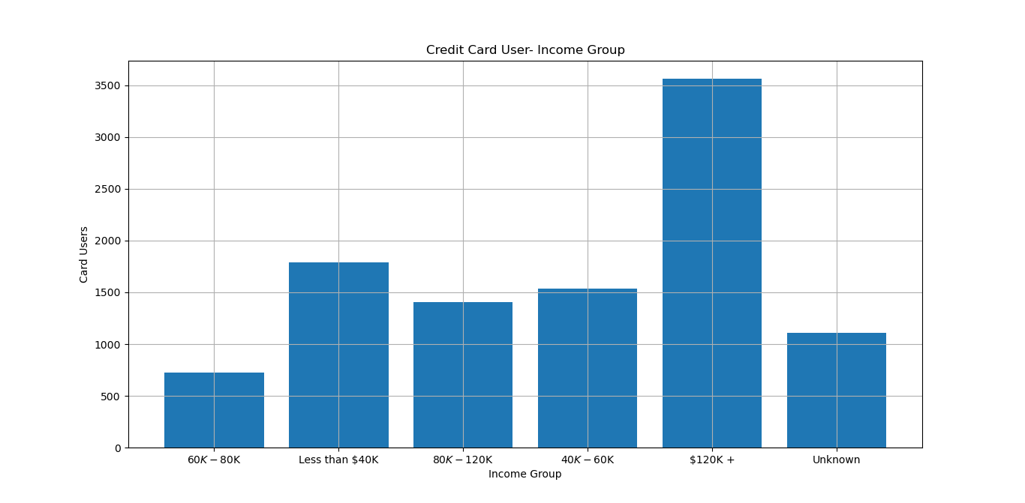

CHAPTER 8
CONCLUSION

This program is used to analyse the data store in a CSV file using Python’s DataFrame and visualization techniques by Matplotlib. The program generates line chart or bar graph based on the choice given by user. Using the different plotting method, the data related to the credit card details of different customers can be analysed and it is also possible to update the existing csv file with latest values too.

The program can be used in general analysis and also in banks, government offices to obtain an accurate representation of money transferring occurring via credit cards.

CHAPTER 9
REFERENCES

- Informatics Practices - Class XII By : Sumita Arora

- Website: https://www.w3resource.com

- Website : https://pandas.pydata.org/pandas-docs/stable/reference/api/pandas.read_csv.html

- Website : www.python.org

